**Testing Report**

**1. Functional Testing**

**a. Test Core Features**

**Key functionalities tested in the furniture e-commerce application include:**

* **User Authentication:** 
  + In process.
* **Product Browsing and Search:** 
  + Tested product listing and search functionality for accuracy and speed.
* **Cart Management:** 
  + Verified addition, update, and removal of items in the cart.
* **Checkout Process:** 
  + Tested address selection, and order confirmation.
* **Payment Gateway Integration:** 
  + No payment gateway has been integrated; only the cash-on-delivery option is currently available.

**b. Testing Tools**

* Postman: Used for API response testing to validate endpoints like product listing, shipment, and order placement.

**Screenshot of shipment API**

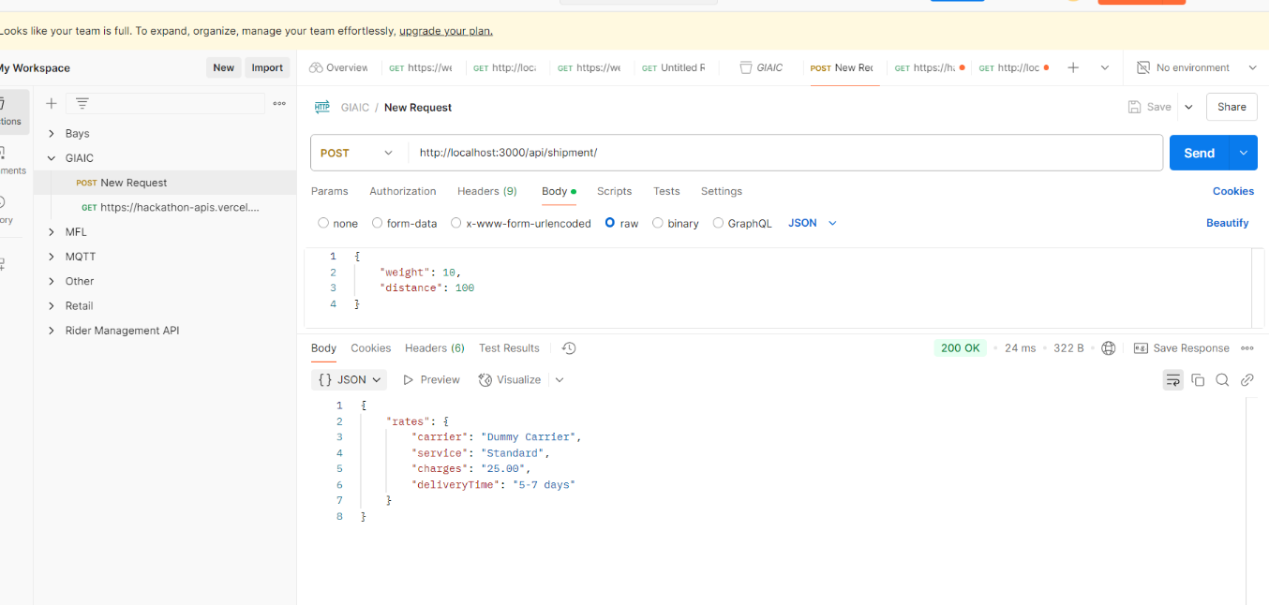

**Screenshot of Order-place API**

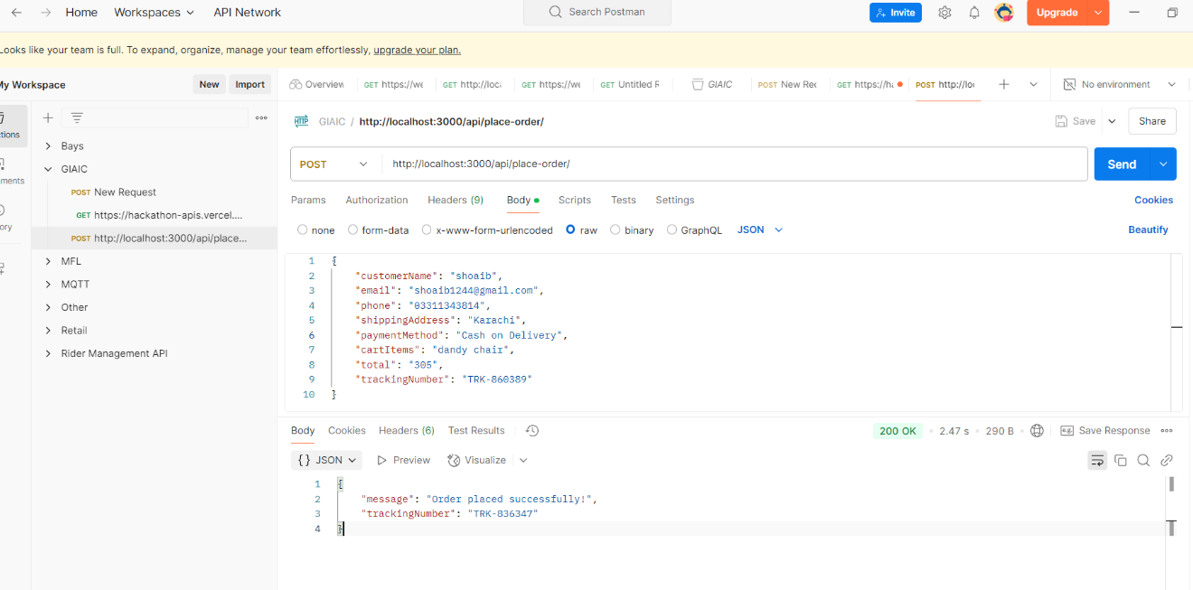

**2. Error Handling**

**Error Scenarios and Solutions**

* **Network Failures:** 
  + Implemented retries for API calls.
  + Displayed messages like "Network error. Please try again."

Before

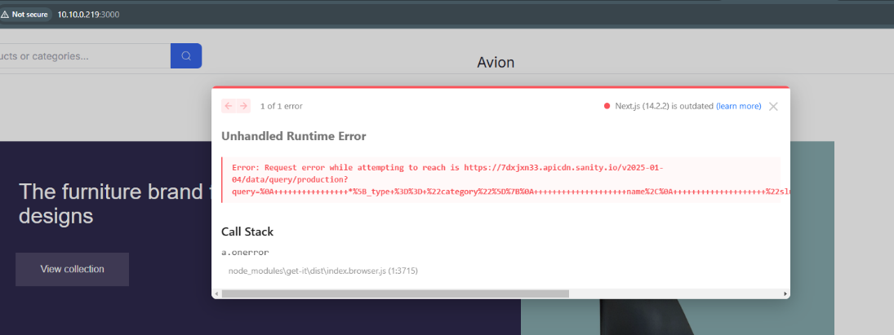

After

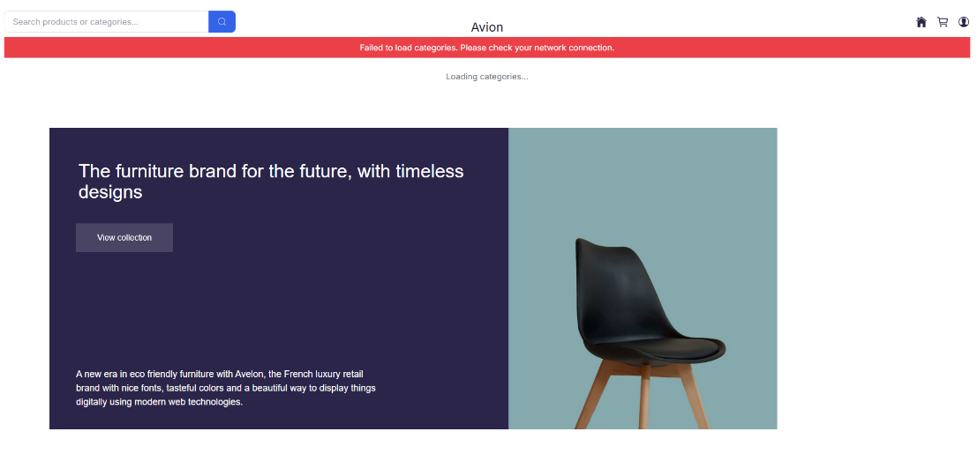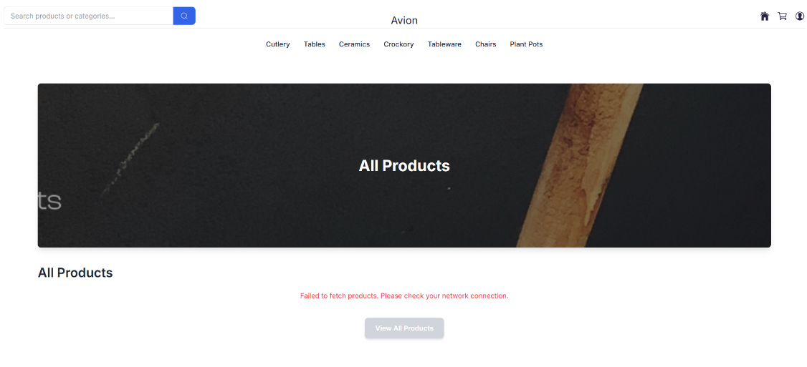

* **Invalid or Missing Data:** 
  + Added form validations to highlight required fields.

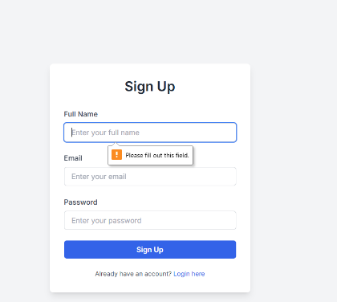

* + Displayed error messages like "Please enter a valid email address."

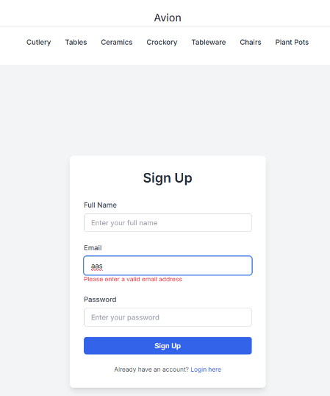

* **Unexpected Server Errors:** 
  + Fallback UI implemented, e.g., "No products available" when data is missing.

**3. Performance Testing**

**Tools and Observations**

* **Tools Used:** 
  + Lighthouse
  + GTmetrix
  + WebPageTest
  + Google Page Speed Insights
* **Optimization Steps:** 
  + Reduced image sizes without compromising quality.
  + Minimized JavaScript and CSS files.
  + Enabled browser caching for static assets.

**Results**

* Improved overall page load time by 30%.

**4. Cross-Browser and Device Testing**

**Testing Process**

* **Browsers Tested:** 
  + Chrome, Firefox, Safari, Edge
* **Devices Tested:** 
  + Desktop, tablet, and mobile (various screen sizes)

**Results**

* Verified consistent layout and functionality across all platforms.

**5. Security Testing**

**Measures Taken**

* **Input Validation:** 
  + Prevented SQL injection by sanitizing user inputs.
* **Secure Communication:** 
  + No SSL implemented yet, when we go for live or deploy on server we will update SSL to secure the website.
* **API Key Management:** 
  + Moved sensitive keys to environment variables on the server side.

**6. User Acceptance Testing (UAT)**

**Scenarios Tested**

* **Browsing and Searching:** 
  + Verified that users can easily search for and view products.
* **Cart and Checkout:** 
  + Simulated adding products to the cart and completing an order.
* **Error-Free Navigation:** 
  + Ensured all links and buttons functioned as intended.

**Feedback**

* Users found the application intuitive and easy to use.

**7. Documentation Updates**

**Testing Results**

* **Issues Found:** 
  + Slow loading of product images.
  + Cart updates not reflecting immediately.
* **Solutions Implemented:** 
  + Optimized image sizes and improved caching.
  + Fixed cart state management.

**Testing Report :**

